ASSIGNMENT 1
1. Explain the difference between frontend, backend, and full-stack development with
suitable real-world examples.
Ans- Frontend development is the part of a website or application that users directly see and interact with. It’s everything you experience in your browser — the design, buttons, menus, text . It uses languages like HTML, CSS, JavaScript and Frameworks/Libraries: React, Angular, Vue.js, Bootstrap
Real-world example: Imagine Netflix — the movie thumbnails, play buttons, and navigation menus you click on are part of the frontend.
Main focus:User interface (UI), user experience (UX), and responsiveness across devices.
Backend Development:Backend development is the “behind-the-scenes” part of a website or app that users don’t see. It handles data storage, security, and communication between the frontend and the database.
Technologies used:Languages: Python, Java, Node.js, PHP, Ruby Databases: MySQL, MongoDB, PostgreSQL and Frameworks: Django, Express.js, Spring Boot
Real-world example:
When you log in to Netflix, the backend checks your username and password in the database, fetches your watch history, and sends that data back to the frontend to display.
This all happens invisibly on servers.
Main focus:Server logic, database management, and APIs
Full-Stack Development:A full-stack developer works on both the frontend and backend parts of a project — designing user interfaces and writing server logic.
Technologies used:A mix of both frontend and backend tools Example Stack: MERN Stack (MongoDB, Express.js, React, Node.js)
Real-world example:
Suppose you build a food delivery app:You create the user interface (frontend) showing menus and orders.
Main focus:End-to-end application development — from user experience to server-side logic and databases.
2. Create a simple diagram showing how the client-server model works in web architecture.
Ans-
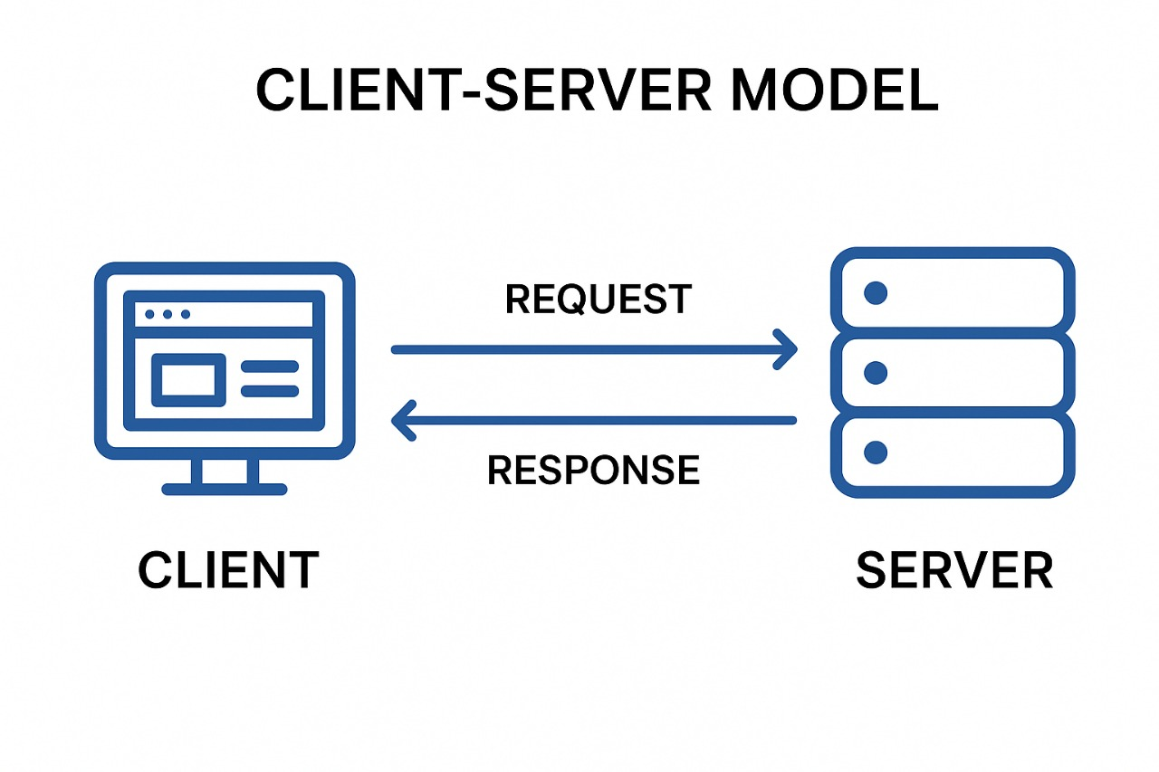

3. Describe how a browser requests and displays a web page from a web server.
Ans- When a user enters a website URL, the browser first contacts the DNS to find the server’s IP address. It then sends an HTTP or HTTPS request to that web server asking for the web page. The server processes the request and responds with HTML, CSS, and other necessary files. Finally, the browser interprets these files and displays the complete web page on the screen.
4. Identify and list the tools required to set up a web development environment. Explain the
purpose of each.
Ans-
- Code Editor: Used to write and edit HTML, CSS, and JavaScript code efficiently.
- Web Browser: Helps test and debug web pages using built-in developer tools.
- Local Server: Runs and tests dynamic websites on your computer.
- Version Control System: Tracks and manages changes made to the code.
- Package Manager: Installs and manages project libraries and dependencies.
- Framework/Library: Provides pre-built code structures to speed up development.
- Database: Stores and retrieves website or application data.
- Testing Tools: Checks code for errors and ensures proper functionality.
- Deployment Tools: Hosts and publishes websites on the intern.
10.Design Tools: Helps create and plan user interfaces and layouts visually.

5. Explain what a web server is and give examples of commonly used servers.
Ans- A web server is a computer or software that stores, processes, and delivers web pages to users over the internet when requested through a browser. It uses the HTTP or HTTPS protocol to handle communication between the client (browser) and the server. Web servers manage website files like HTML, CSS, and images and send them to users on request.
Examples of commonly used web servers: Apache HTTP Server, Nginx, Microsoft IIS, and LiteSpeed.

6. Define the roles of a frontend developer, backend developer, and database administrator
in a project.
Ans- A frontend developer designs and builds the visual parts of a website that users interact with, using technologies like HTML, CSS, and JavaScript.
A backend developer manages the server-side logic, application functionality, and communication between the frontend and the database, using languages like Python, Java, or Node.js.
A database administrator (DBA) is responsible for designing, managing, securing, and maintaining the database to ensure data is stored efficiently and accessed reliably by the application.

7. Install VS Code and configure it for HTML, CSS, and JavaScript development. Take a
screenshot of the setup.
Ans-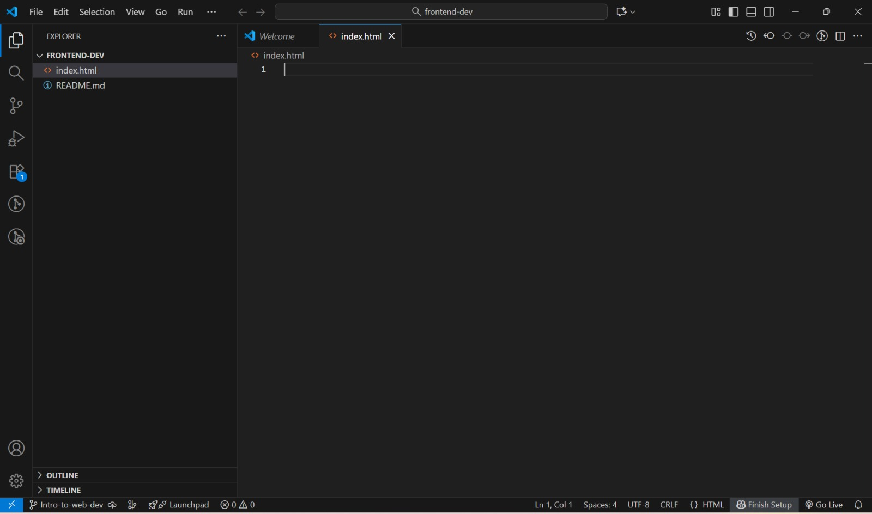

8. Explain the difference between static and dynamic websites. Provide an example of
each.
Ans-A static website displays fixed content that does not change unless manually updated. It is simple, fast, and built using HTML and CSS. Example: a personal portfolio site.
A dynamic website generates content dynamically based on user interaction or data from a database. It requires server-side scripting like PHP, Node.js, or Python. Example: an e-commerce site like Amazon, where product listings and prices change based on the database.

9. Research and list five web browsers. Explain how rendering engines differ between
them.
Ans-Google Chrome – Uses the Blink engine, which focuses on speed, modern web standards, and efficient JavaScript execution.
Mozilla Firefox – Uses Gecko, designed for flexibility, strong support for web standards, and security features.
Microsoft Edge – Also uses Blink (after switching from EdgeHTML), providing fast performance and compatibility with Chrome extensions.
Safari – Uses WebKit, optimized for Apple devices with high energy efficiency and smooth rendering.
Opera – Uses Blink, similar to Chrome, with additional built-in features like a VPN and ad blocker.

10. Draw a labeled diagram showing the basic web architecture flow — client, server,
database, and APIs.
Ans-